

PERSOL

GROUP MEMBERS

Student Id Student Name

Student 1367004 Hasan Lodhi

Student 1365428 Azhar Shah

Student 1366129 Muhammad Arham

CURRICULUM BATCH

7062 2202C2

FACULTY

MISS MEHWISH ASHRAF

CO-ORDINATOR

MISS: SYEDA ARIBA ALI

HOME PAGE



PRODUCT CATEGORY



PRODUCT IMAGES



SUBSCRIBE NOW



VISITOR COUNTER



FOOTER 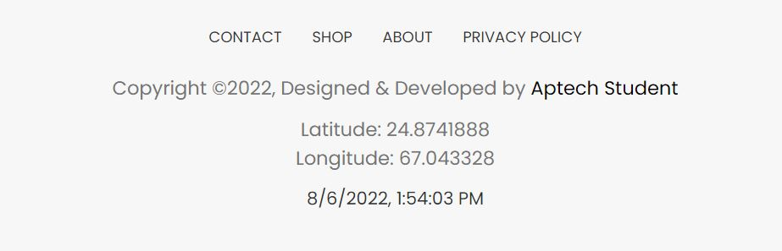LOGIN PAGE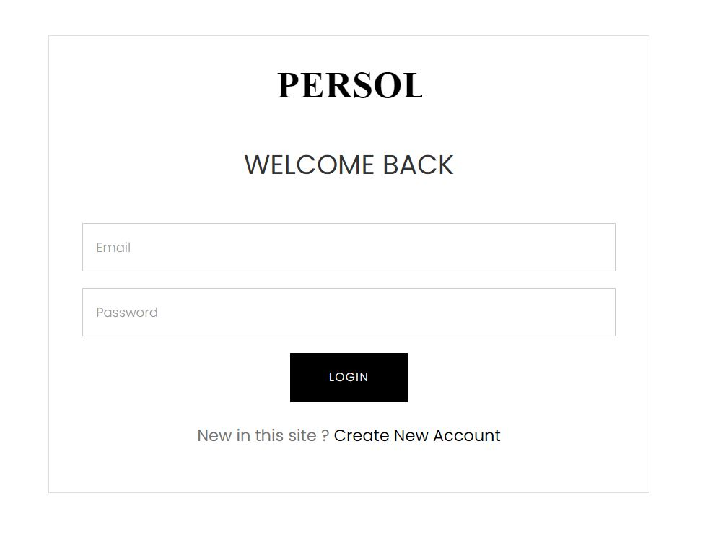

SIGN UP PAGE

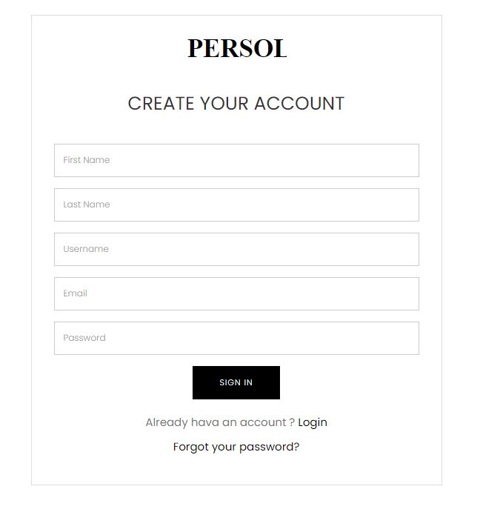

FAQs

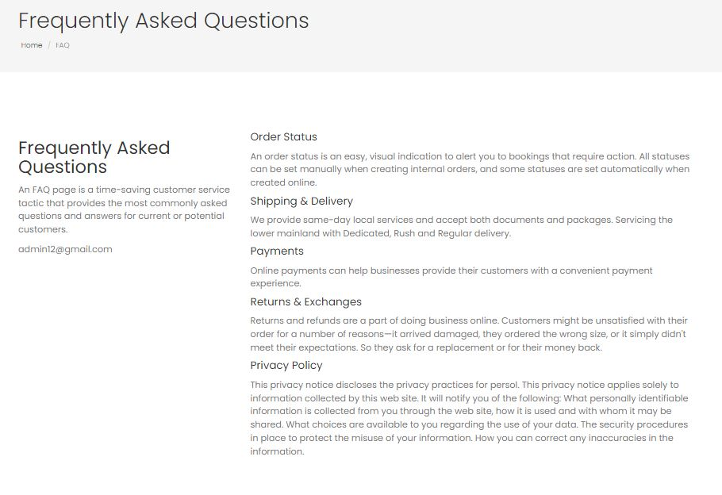

ABOUT US



CONTACT US

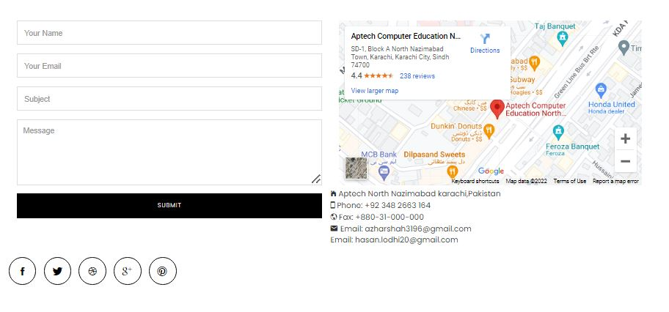

CART

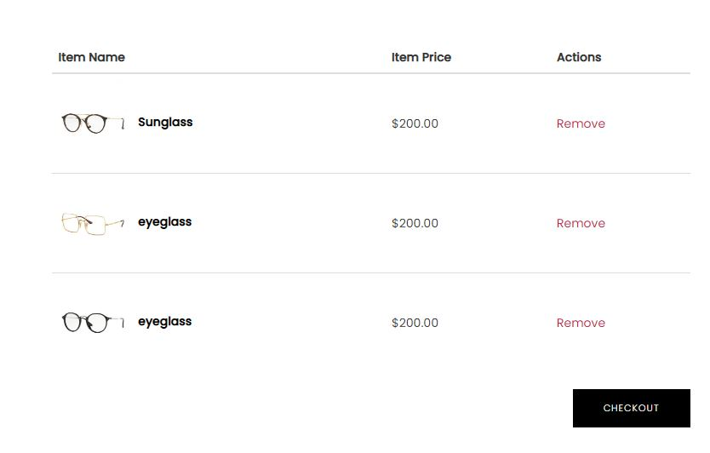

CHECKOUT

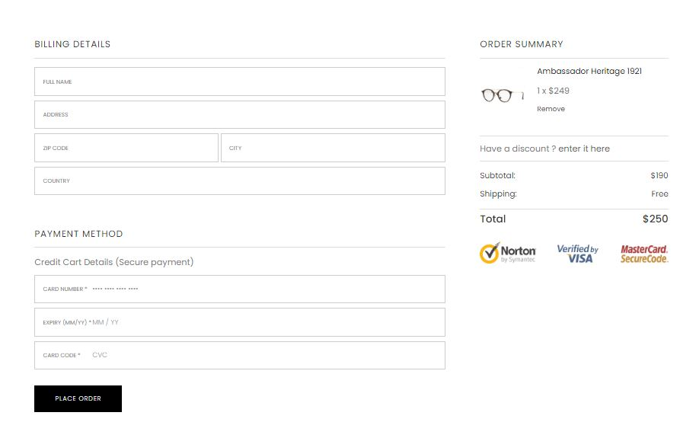

PAYMENT CONFORMATION

